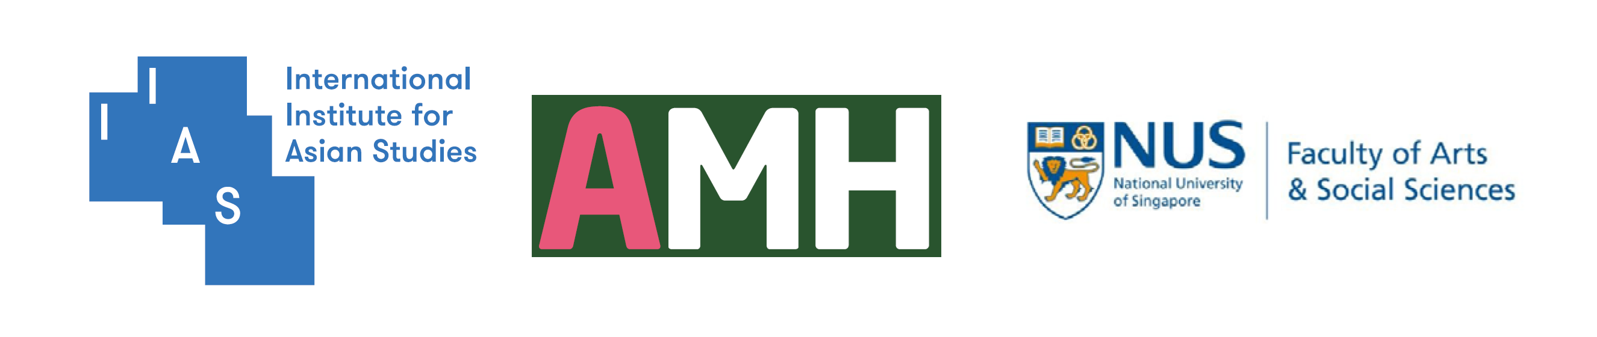
The 2024 Global Mobility Humanities Conference (GMHC)

Application Form (Session)

Organiser |  |  |  | E-mail
Academic Affiliation (Institution and Country)
Participation Type | On-site  (In person) | Online |  | Number of  Presentations
Type of Session | 7/7 |  | Debate |  |  | Panel
Title
of the Session
Session  Proposal  300 Words | - Session Proposal and Title should be written in English ONLY.  - Individual presentation abstracts of the panel proposal should be submitted separately. See the following form.

Individual Presenter # 1
Name |  | E-mail
Academic Affiliation (Institution and Country)
Academic
Interests
Title
Abstract  300 Words | - Abstract and Title should be written in English ONLY.
Biographical Note
100 Words

* Please copy and paste the form above for each presenter as many as needed.

